Crypto Focused Hedge Funds and Venture Capital- Market Map 2017
The market capitalization of crypto currencies recently reached $181 billion.  Over $1 billion of initial coin offerings (ICOs) were issued year to date by August 2017, a 5x increase of all of 2016.  Here are 55 funds specializing in trading the 850+ crypto currencies and investing in blockchain apps.  To estimate the scale that these funds may reach, note that hedge fund penetration of U.S. public equities is approximately 3%.  www.slimstrategic.com  Venture capital & biz development | Outperform Bitcoin on a risk adjusted basis | 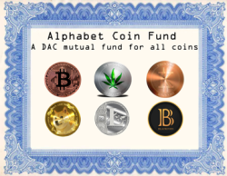  World’s first closed end crypto fund: NAV $4m+ | AURYN CAPITAL  Manager turned $15k into $3m | Institutional grade– min. $500k investment | Bridge between crypto & real world; tokenizes investment funds | Institutional approach to crypto investing | Web 3.0 Crypto currencies and protocols
First and leading crypto VC fund | Institutional approach to crypto investing | Decentralizing markets and liberating data | Transparent, uncorrelated, high-growth, portfolio | Professional investments in digital assets | Crypto hedge fund; $25,000 min. investment | Aims for safe, familiar access to crypto | Cryptolotus invests in ‘philosophically sound’ cryptos
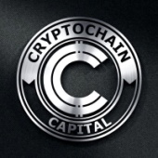  Crypto currency investor | 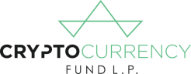  SEC registered crypto hedge fund | Investments in crypto and blockchain | Diversified portfolio of over 50 tokens | Experienced investor in domains; now in crypto also | Investor platform with over $1.6 billion across 560 projects. | Peer to peer ether loans | Seeks high yield, uncorrelated returns in low return world.
Digital asset management in the blockchain | First VC fund in China focused on blockchain | Crypto asset fund | ICO which lends against public stock | Invests in tokens built to address real world problems | Grasshopper Capital: a crypto asset fund | 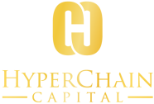  Since 2013; participated in first ICO | Tools and investment platform for crypto
Iterative Capital Management crypto investment fund | Accelerate bridge between corporate and blockchain | First blockchain mining fund | Blockchain focused VC | Crypto hedge fund | Crypto VC and development co. | VC Economics, public co liquidity | Founded 2003; now crypto focus
Placeholder Capital  Crypto VC fund of Union Square Ventures alum | Institutional quality crypto investors | POLYCHAIN CAPITAL  Active management of crypto assets | Largest bitcoin fund | Blockchain investor | Incubator since 2011 focused on blockchain | Crypto hedge fund for LATAM families | Blockchain accelerator and hedge fund
Tokens as a service to subscribe to funds income stream | TETRAS CAPITAL  Diversified blockchain investor | 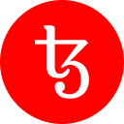  VC for blockchain developers | Crypto fund and investor tool | Crypto index fund | VC fund with low minimums | Investor in blockchain companies

